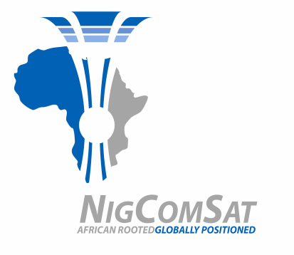

THE PROCUREMENT PROCESS ADOPTED BY NIGCOMSAT LIMITED FROM 2018, 2019, 2020, AND 2021 FISCAL YEAR.
S/N | YEAR | ADOPTED METHOD
1 | 2018 | National Competitive Bidding (NCB)/ Selective Tendering
2 | 2019 | National Competitive Bidding (NCB)/ Selective Tendering
3 | 2020 | National Competitive Bidding (NCB)/ Selective Tendering
4 | 2021 | National Competitive Bidding (NCB)/ Selective Tendering

